Data Structure with Min/Max Operation.
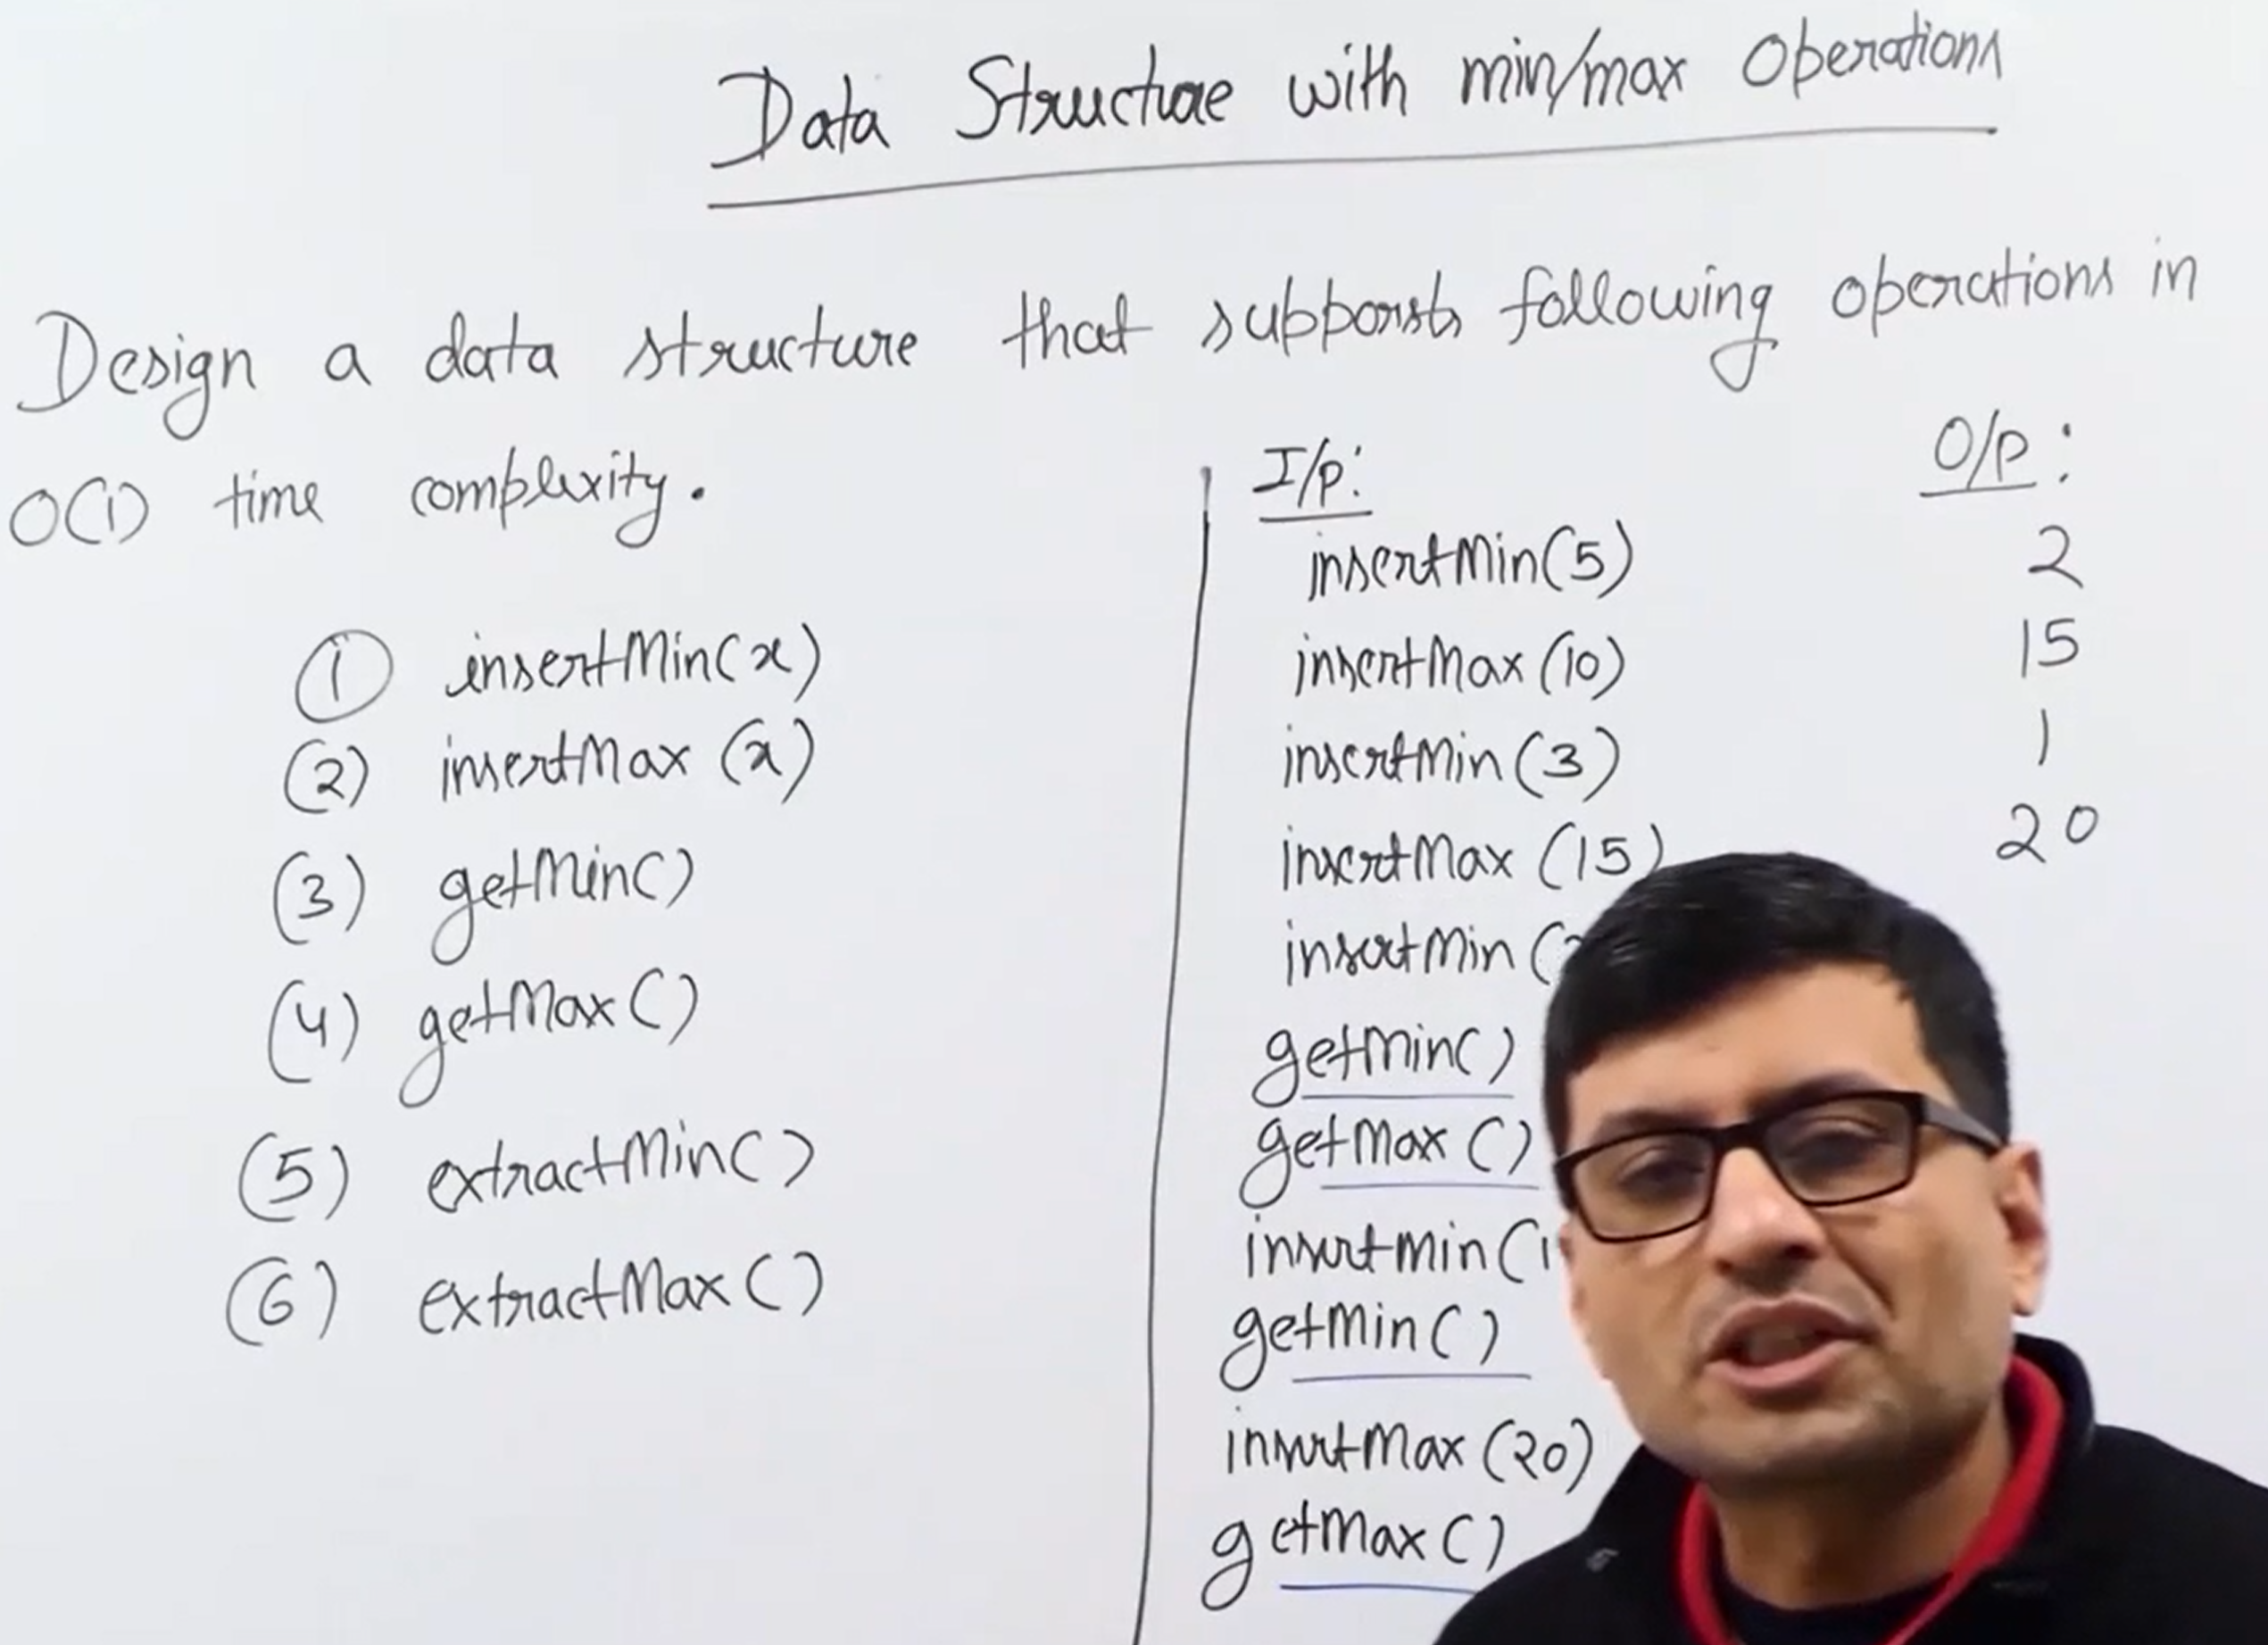
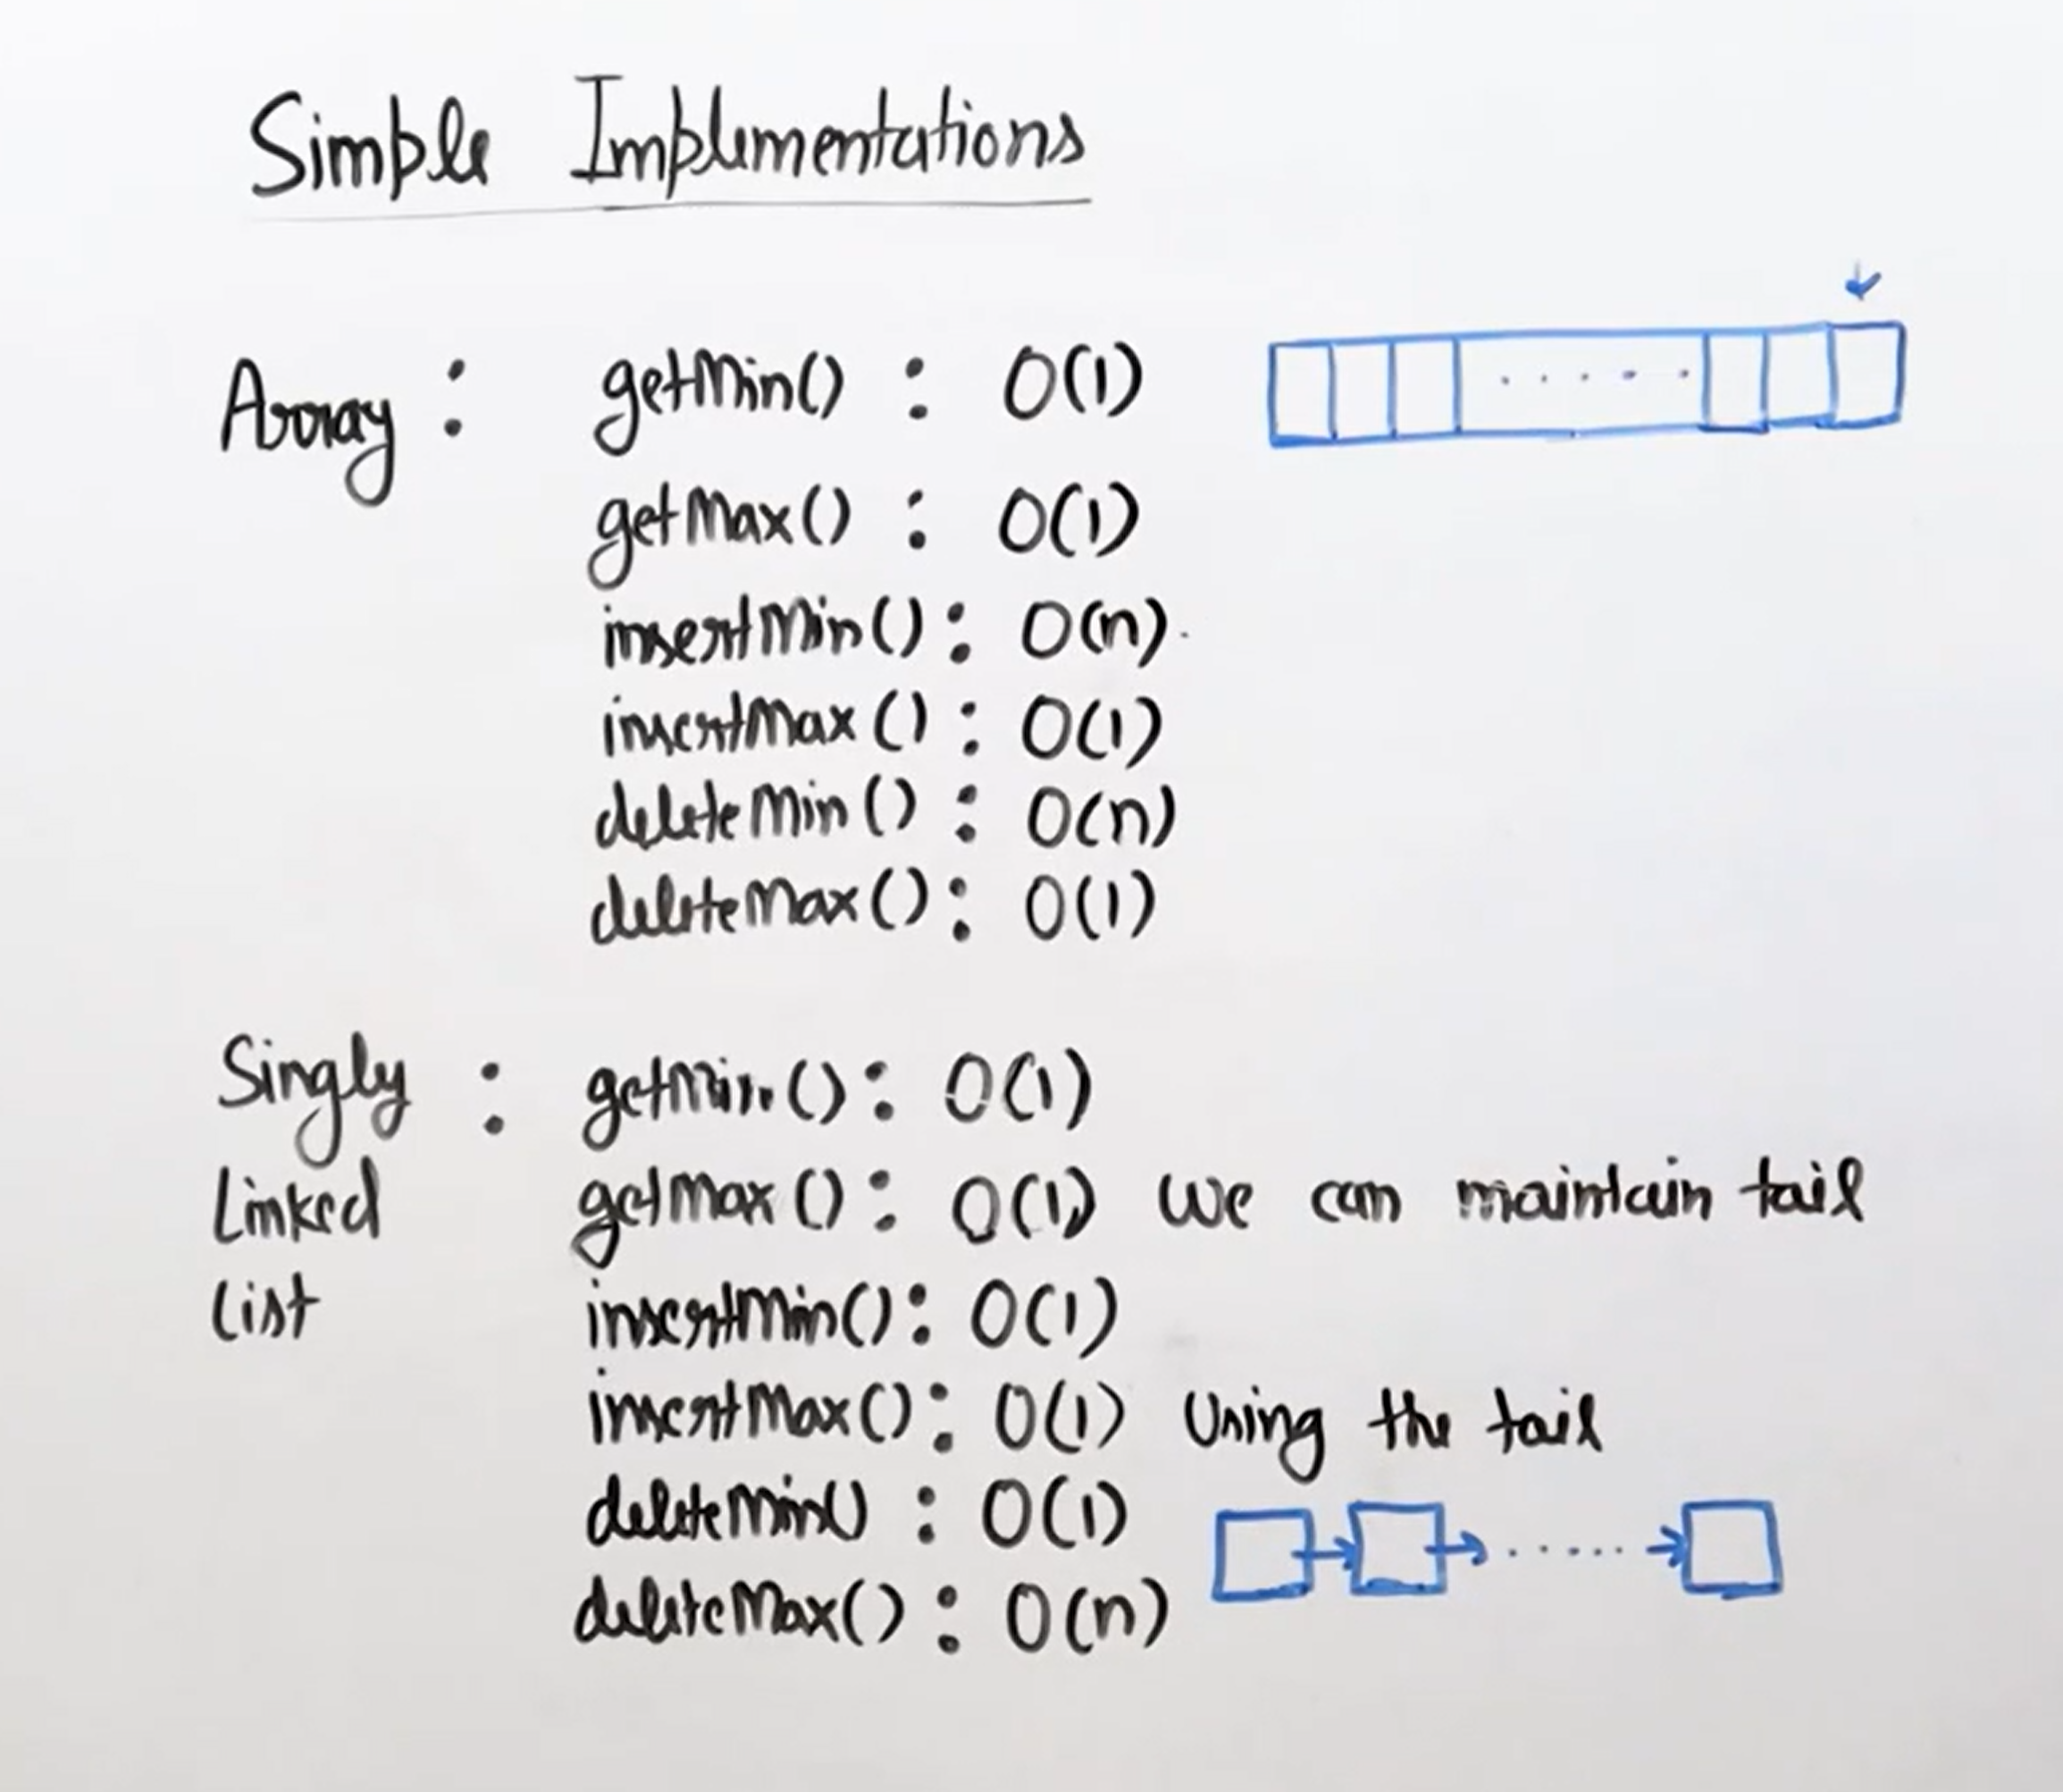
The both approaches are not good to implement then we use the deque as the efficient implementation.


